**EXPERIMENT 3**

Q1- Write HTML code to create table having border and alternate columns background colours. Final output should be like this:

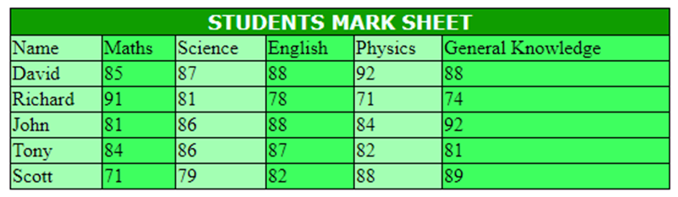

Input:-

<!Doctype html>

<html>

<head></head>

<style>

table{

border: 1px solid black;

border-collapse: collapse;

border-spacing: 2px;

width: 40%;

}

th,td{ border: 1px solid black; }

td:nth-child(even) {background-color: #3eff5f;}

td:nth-child(odd) {background-color: #a3ffb3;}

</style>

<body>

<table>

<th bgcolor="#0F9D00" colspan="6" style="font-family:Verdana; color: azure;">

<b>STUDENTS MARK SHEET</b></th>

<tr><td>Name</td><td>Maths</td><td>Science</td><td>English</td><td>Physics</td><td>General Knowledge</td></tr>

<tr><td>David</td><td>85</td><td>87</td><td>88</td><td>92</td><td>88</td></tr>

<tr><td>Richard</td><td>91</td><td>81</td><td>78</td><td>71</td><td>74</td></tr>

<tr><td>John</td><td>81</td><td>86</td><td>88</td><td>84</td><td>92</td></tr>

<tr><td>Tony</td><td>84</td><td>86</td><td>87</td><td>82</td><td>81</td></tr>

<tr><td>Scott</td><td>71</td><td>79</td><td>82</td><td>88</td><td>89</td></tr>

</table>

</body>

Output:-

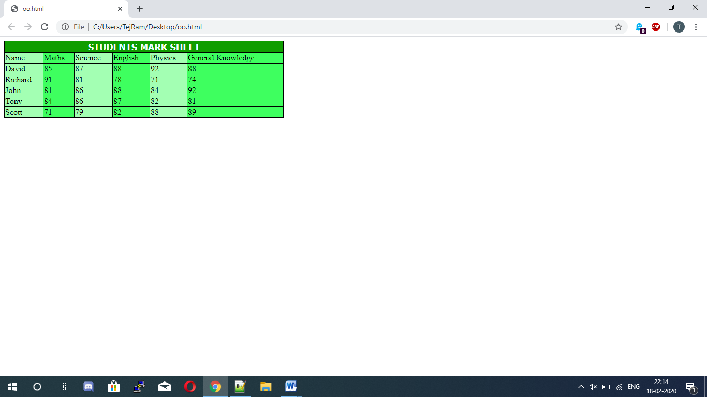

Q2- Write a HTML code to generate following output:-

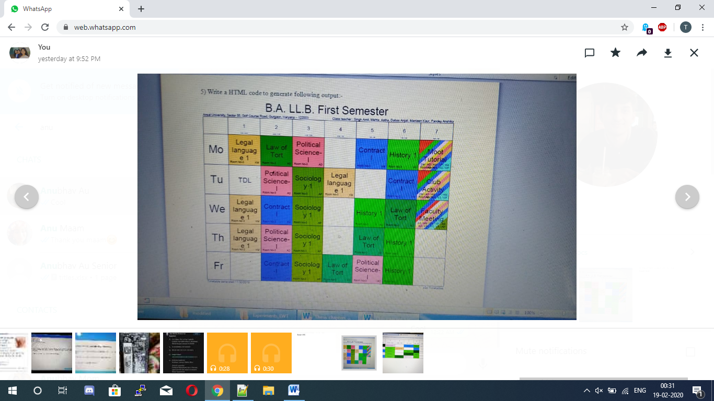

Input:-

<html>

<body>

<style type="text/css">

.tg {border-collapse:collapse;border-spacing:0;}

.tg td{font-family:Arial, sans-serif;font-size:14px;padding:10px 5px;border-style:solid;border-width:1px;overflow:hidden;word-break:normal;border-color:black;}

.tg th{font-family:Arial, sans-serif;font-size:14px;font-weight:normal;padding:10px 5px;border-style:solid;border-width:1px;overflow:hidden;word-break:normal;border-color:black;}

.tg .tg-cmwg{background-color:#ffccc9;text-align:center;vertical-align:top}

.tg .tg-baqh{text-align:center;vertical-align:top}

.tg .tg-v4zq{background-color:#3531ff;text-align:center;vertical-align:top}

.tg .tg-0lax{text-align:left;vertical-align:top}

.tg .tg-8gin{background-color:#ffcc67;color:#000000;text-align:center;vertical-align:top}

.tg .tg-1f4r{background-color:#036400;text-align:center;vertical-align:top}

.tg .tg-l5iw{background-color:#32cb00;text-align:center;vertical-align:top}

.tg .tg-k3lo{background-color:#34ff34;text-align:center;vertical-align:top}

</style>

<table class="tg">

<tr>

<th class="tg-0lax"></th>

<th class="tg-baqh">1<br><br>9:15 - 10:15</th>

<th class="tg-baqh">2<br><br>10:20 - 11:20</th>

<th class="tg-baqh">3<br><br>11:25 - 12:25</th>

<th class="tg-baqh">4<br><br>12:30 - 1:30</th>

<th class="tg-baqh">5<br><br>1:35 - 2:35</th>

<th class="tg-baqh">6<br><br>2:40 - 3:40</th>

<th class="tg-baqh">7<br><br>3:45 - 4:45</th>

</tr>

<tr>

<td class="tg-baqh">Mo</td>

<td class="tg-8gin">Legal Language 1</td>

<td class="tg-1f4r">Law of Tort</td>

<td class="tg-cmwg">Political Science - I</td>

<td class="tg-baqh"></td>

<td class="tg-v4zq">Contract I</td>

<td class="tg-l5iw">History 1</td>

<td class="tg-baqh">Moot Tutorial</td>

</tr>

<tr>

<td class="tg-baqh">Tu</td>

<td class="tg-baqh">TDL</td>

<td class="tg-cmwg">Political Science - 1</td>

<td class="tg-k3lo">Sociology 1</td>

<td class="tg-8gin">Legal language 1</td>

<td class="tg-baqh"></td>

<td class="tg-v4zq">Contract I</td>

<td class="tg-baqh">Club Activity</td>

</tr>

<tr>

<td class="tg-baqh">We</td>

<td class="tg-8gin">Legal language 1</td>

<td class="tg-v4zq">Contract I</td>

<td class="tg-k3lo">Sociology 1</td>

<td class="tg-baqh"></td>

<td class="tg-l5iw">History 1</td>

<td class="tg-1f4r">Law of Tort</td>

<td class="tg-baqh">Faculty Meeting</td>

</tr>

<tr>

<td class="tg-0lax">Th</td>

<td class="tg-8gin">Legal language 1</td>

<td class="tg-cmwg">Political Science - 1</td>

<td class="tg-k3lo">Sociology 1</td>

<td class="tg-baqh"></td>

<td class="tg-1f4r">Law of Tort</td>

<td class="tg-l5iw">History 1</td>

<td class="tg-baqh"></td>

</tr>

<tr>

<td class="tg-0lax">Fr</td>

<td class="tg-baqh"></td>

<td class="tg-v4zq">Contract I</td>

<td class="tg-k3lo">Sociology 1</td>

<td class="tg-1f4r">Law of Tort</td>

<td class="tg-cmwg">Political Science - 1</td>

<td class="tg-l5iw">History 1</td>

<td class="tg-baqh"></td>

</tr>

</table>

</body>

</html>

Output:-

